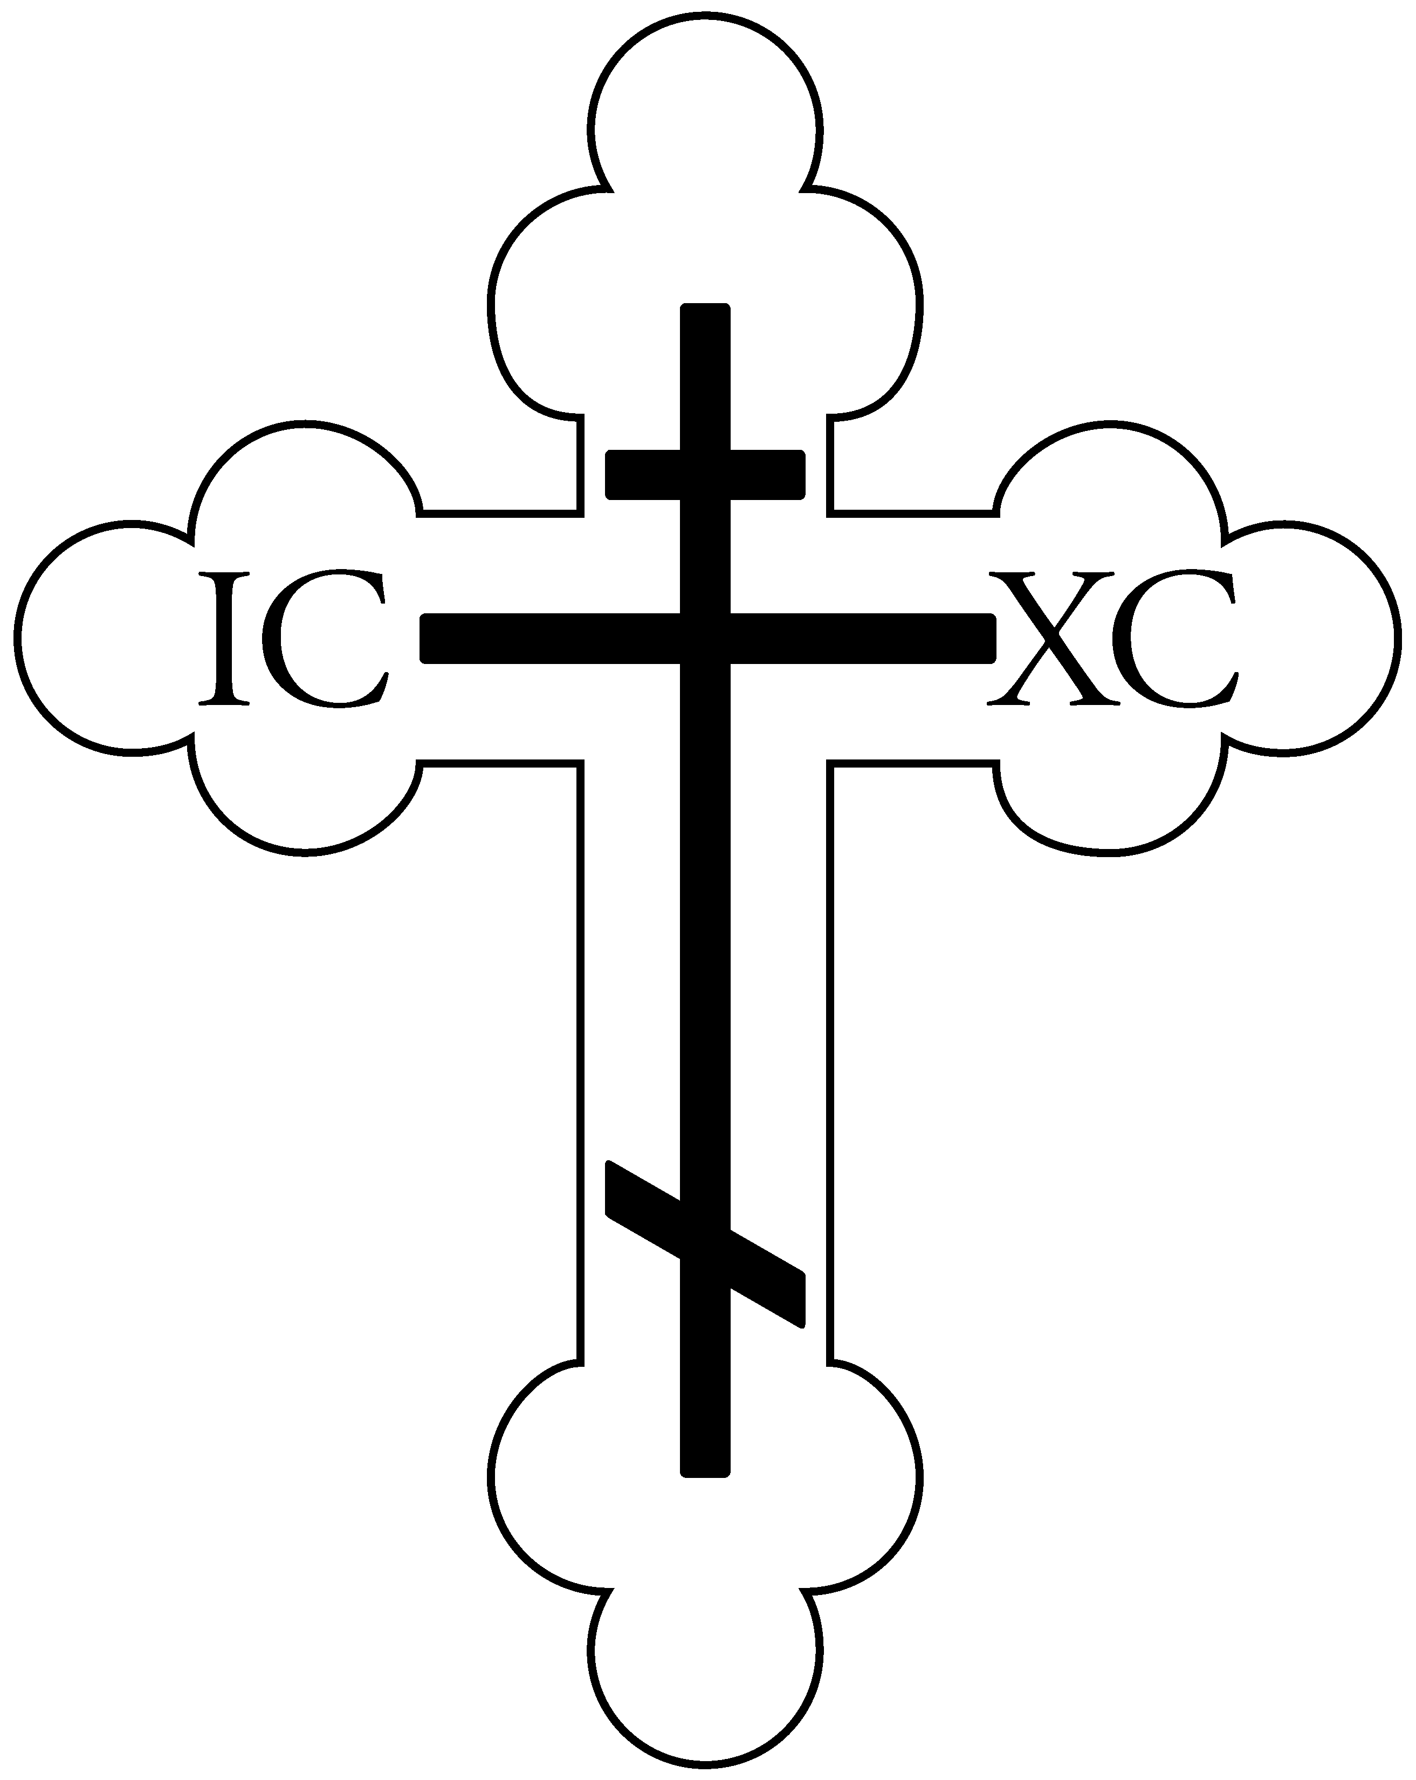

St. Vladimir Orthodox Church
812 Grand Street, Trenton, NJ 08610
(609) 393-1234 website: http://saintvladimir.org/

Sunday of the Publican and the Pharisee
Beginning of the Lenten Triodion
January 28, 2018
Troparion – Tone 1
When the stone had been sealed by the Jews, while the soldiers were guarding Thy most pure body, Thou didst rise on the third day, O Savior, granting life to the world. The powers of heaven therefore cried to Thee, O Giver of Life: “Glory to Thy Resurrection, O Christ! Glory to Thy ^Kingdom!// Glory to Thy dispensation, O Thou who lovest of mankind!”
Troparion – Tone 4
Today the Church of Russia forms a chorus in joy, praising her new martyrs and confessors; hierarchs and priests, royal passion-bearers, right-believing princes and princesses, venerable men and women, and all Orthodox Christians. Having laid down their life for faith in Christ during the days of godless persecution, they preserved the truth by the shedding of blood.// By their protection, O long-suffering Lord, preserve our land in Orthodoxy till the end of the age.
Troparion – Tone 4
Let us flee from the pride of the Pharisee! Let us learn humility from the Publican's tears! Let us cry to our Savior: “Have mercy on us,// O only merciful One!”
Kontakion – Tone 4
Thou didst shine forth from the mount like lightning, glorifying Christ through thy struggles and death as a martyr.// Therefore, thou hast received an unfading crown, O Great-martyr Neophýtus.
Prokeimenon – Tone 1
Let Thy mercy, O Lord, be upon us as we have set our hope on Thee!
v: Rejoice in the Lord, O ye righteous! Praise befits the just!
Prokeimenon – Tone 7
God is our refuge and strength, a help in afflictions that severely befall us.
Sunday of the Publican and the Pharisee Beginning of Lenten Triodion
The Sunday after the Sunday of Zacchaeus is devoted to the Publican and the Pharisee. At Vespers the night before, the TRIODION (the liturgical book used in the services of Great Lent) begins.
Two men went to the Temple to pray. One was a Pharisee who scrupulously observed the requirements of religion: he prayed, fasted, and contributed money to the Temple. These are very good things, and should be imitated by anyone who loves God. We who may not fulfill these requirements as well as the Pharisee did should not feel entitled to criticize him for being faithful. His sin was in looking down on the Publican and feeling justified because of his external religious observances.
The second man was a Publican, a tax-collector who was despised by the people. He, however, displayed humility, and this humility justified him before God (Luke 18:14).
The lesson to be learned is that we possess neither the Pharisee’s religious piety, nor the Publican’s repentance, through which we can be saved. We are called to see ourselves as we really are in the light of Christ’s teaching, asking Him to be merciful to us, deliver us from sin, and to lead us on the path of salvation.
Epistle: 2 Timothy 3:10-15
But you have carefully followed my doctrine, manner of life, purpose, faith, longsuffering, love, perseverance, persecutions, afflictions, which happened to me at Antioch, at Iconium, at Lystra – what persecutions I endured. And out of them all the Lord delivered me. Yes, and all who desire to live godly in Christ Jesus will suffer persecution. But evil men and impostors will grow worse and worse, deceiving and being deceived. But you must continue in the things which you have learned and been assured of, knowing from whom you have learned them, and that from childhood you have known the Holy Scriptures, which are able to make you wise for salvation through faith which is in Christ Jesus.
Gospel: Luke 18:10-14
“Two men went up to the temple to pray, one a Pharisee and the other a tax collector. The Pharisee stood and prayed thus with himself, ‘God, I thank You that I am not like other men – extortioners, unjust, adulterers, or even as this tax collector. I fast twice a week; I give tithes of all that I possess.’ And the tax collector, standing afar off, would not so much as raise his eyes to heaven, but beat his breast, saying, ‘God, be merciful to me a sinner!’ I tell you, this man went down to his house justified rather than the other; for everyone who exalts himself will be humbled, and he who humbles himself will be exalted.”
Service Schedule for the week of January 28
Today – 9:00 AM Church School, 9:45 AM Hours, 10:00 AM Divine Liturgy followed by Coffee Hour/Chicken
Parmigiana Sandwich Sale and Annual Parish Meeting
Thursday February 1 – 7:00 PM Vespers with Litya – Meeting of our Lord & Savior, Jesus Christ, in the Temple
Friday February 2 – 9:00 AM Divine Liturgy with blessing of candles
Saturday February 3 - 5:00 PM Vespers followed by Confession
Sunday February 4 – 9:00 AM Church School, 9:45 AM Hours, 10:00 AM Divine Liturgy
Weekly Giving
January 21 – 49 adults, 12 youth, $2,220
Parish Announcements
If you would like your house blessed, please sign the sheet on the table across from the candle desk and Father Volodymyr will contact you to schedule a time.
The Annual Parish Meeting will be held today after coffee hour.
Our parish will host a Mission Service and Lenten meal for NJ and PA parishes on Sunday March 11 at 4:00 PM. More information will be forthcoming.
FREE – If interested please see Father Volodymyr, Melody, or Dottie K.:
Wooden padded office chairs
Two double-size wooden file cabinets
Oak student desks and chairs
Please remember to turn in your blue Stewardship card as soon as possible to Nina Laushell, Ludwig Koerte, or Herman Meyer. Thank you for your continuing support of St. Vladimir Orthodox Church.
Visit our Book Garden Library in Daria Hall! There is a new section which includes books written in Slavic. Simply sign out a book and return it when you are finished. Also check out the primitive painting “The Speckled Hen”, based on the Russian fairytale.
The Ladies Altar Society will be making pierogies on Friday night February 9 and Saturday morning February 10. Many hands are needed to help! Friday night we will peel, cook, and mash the potatoes, and assemble the filling balls for Saturday morning. Saturday morning we will roll the dough, pinch-pinch-pinch, and boil the pierogies. Nadja Nowicki needs the following donations – before buying anything please check with her to make sure you are not duplicating!
- Cash to purchase 50 lbs. of potatoes, 25 lbs. of flour, 3 lbs. of cheddar cheese, and 5-6 lbs. of margarine.
- Plastic freezer and storage bags (approx. 100 of each)
- 10 lbs. onions
Any questions see Nadja Nowicki.
Trip to Israel and Ukraine:
Father Volodymyr is arranging a trip for about 15 people to travel to Israel and Ukraine this spring as follows:
Departure Mon. May 21, JFK airport to Kiev with a connecting flight from Kiev to Israel, arriving Tues. May 22.
7 days and 6 nights in Israel.
Depart Israel Monday May 28, fly to Kiev for 4 days and 3 nights.
Depart May 31 Kiev to JFK.
Airline ticket is approx. $940.
Hotel, bus tour, breakfasts and dinners in Israel $575.
Hotels in Kiev are approx. $30/night (3 nights).
Each traveler should budget for lunches in Israel, as well as 3 meals a day in Kiev and possibly some small activity/entry fees to various tourist attractions.
If you are interested in this trip, please see Father Volodymyr before February 15, which is the last day to book the trip.

