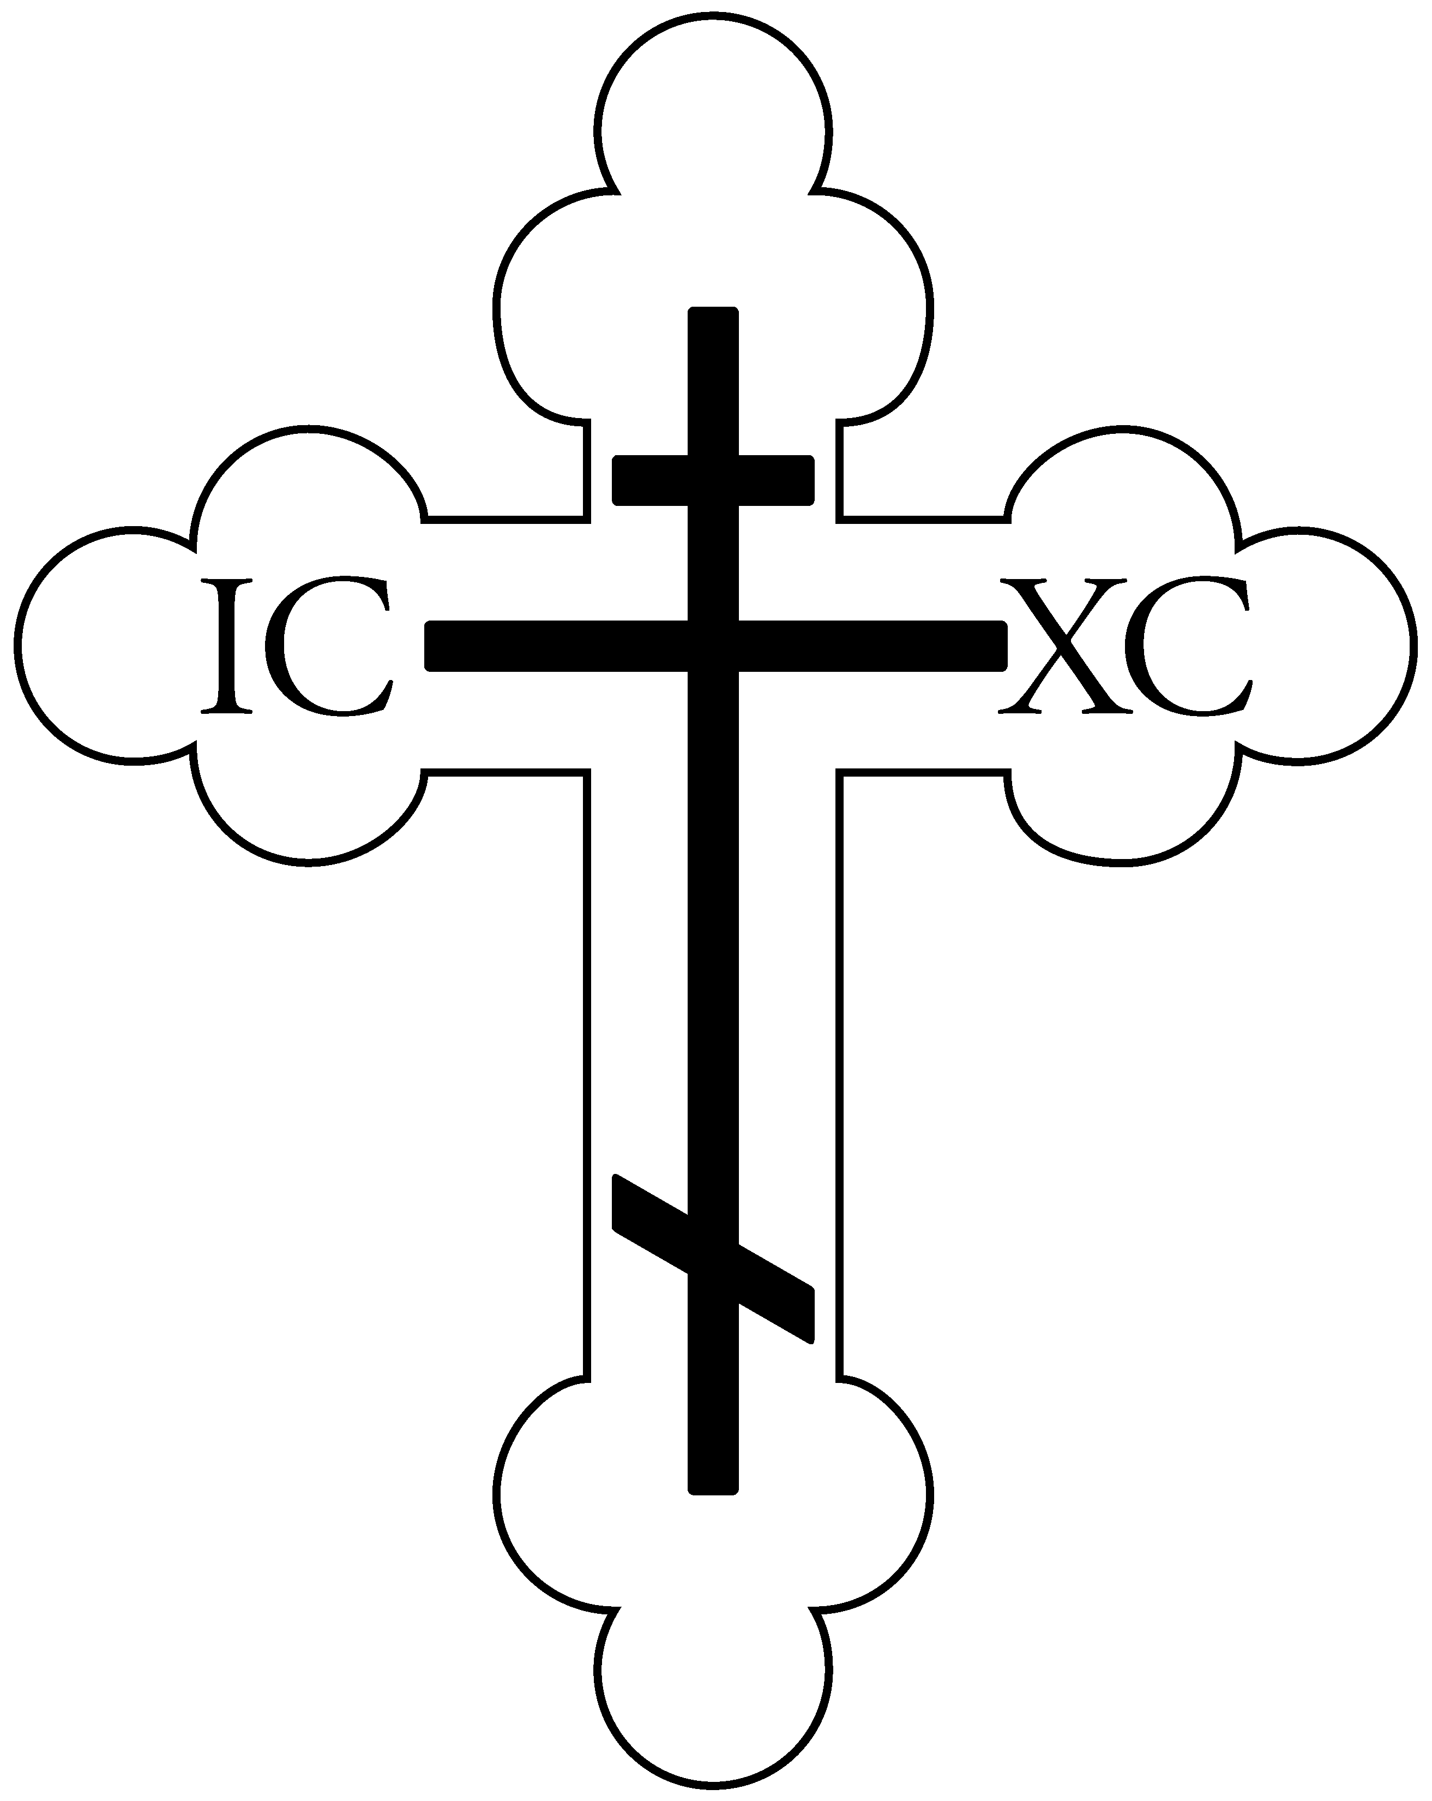

St. Vladimir Orthodox Church
812 Grand Street, Trenton, NJ 08610
(609) 393-1234
Website: saintvladimir.org
Facebook: facebook.com/St-Vladimir-Orthodox-Church-Trenton-NJ-454092552035666

Leavetaking of the Dormition of the Mother of God /
Martyr Lupus, slave of Saint Demetrius of Thessalonica

August 23, 2020
Troparion – Tone 2
When Thou didst descend to death, O Life immortal, Thou didst slay hell with the splendor of Thy Godhead. And when from the depths Thou didst raise the dead, all the powers of heaven cried out:// “O Giver of life, Christ our God, glory to Thee!”
Troparion – Tone 1
In giving birth thou didst preserve thy virginity. In falling asleep thou didst not forsake the world, O Theotokos. Thou wast translated to life, O Mother of Life,// and by thy prayers thou dost deliver our souls from death.
Kontakion – Tone 2
Hell became afraid, O almighty Savior, seeing the miracle of Thy Resurrection from the tomb! The dead arose! Creation, with Adam, beheld this and rejoiced with Thee,// and the world, my Savior, praises Thee forever.
Kontakion – Tone 2
Neither the tomb, nor death, could hold the Theotokos, who is constant in prayer and our firm hope in her intercessions. For being the Mother of Life,// she was translated to life by the One Who dwelt in her virginal womb.
Prokeimenon – Tone 2
The Lord is my strength and my song; / He has become my salvation.
v: The Lord has chastened me sorely, but He has not given me over to death.
Prokeimenon – Tone 3
My soul doth magnify the Lord, / and my spirit hath rejoiced in God my Savior.
Leavetaking of the Dormition of the Mother of God
The Leavetaking of the Feast of the Dormition falls on August 23. The office of the Feast is repeated, except for the entrance, readings, and Litya at Vespers; and the polyeleos and Gospel of the Feast at Matins.
Martyr Lupus, slave of Saint Demetrius of Thessalonica
The Martyr Lupus lived at the end of the third century and beginning of the fourth century, and was a faithful servant of the holy Great Martyr Demetrius of Thessalonica (October 26). Being present at the death of his master, he soaked his own clothing with his blood and took a ring from his hand. With this clothing, and with the ring and the name of the Great Martyr Demetrius, Saint Lupus worked many miracles at Thessalonica. He destroyed pagan idols, for which he was subjected to persecution by the pagans, but he was preserved unharmed by the power of God. Saint Lupus voluntarily delivered himself into the hands of the torturers, and by order of the emperor Maximian Galerius, he was beheaded by the sword.
Epistle: 1 Corinthians 9:2-12
If I am not an apostle to others, yet doubtless I am to you. For you are the seal of my apostleship in the Lord. My defense to those who examine me is this: Do we have no right to eat and drink? Do we have no right to take along a believing wife, as do also the other apostles, the brothers of the Lord, and Cephas? Or is it only Barnabas and I who have no right to refrain from working? Whoever goes to war at his own expense? Who plants a vineyard and does not eat of its fruit? Or who tends a flock and does not drink of the milk of the flock? Do I say these things as a mere man? Or does not the law say the same also? For it is written in the law of Moses, “You shall not muzzle an ox while it treads out the grain.” Is it oxen God is concerned about? Or does He say it altogether for our sakes? For our sakes, no doubt, this is written, that he who plows should plow in hope, and he who threshes in hope should be partaker of his hope. If we have sown spiritual things for you, is it a great thing if we reap your material things? If others are partakers of this right over you, are we not even more? Nevertheless we have not used this right, but endure all things lest we hinder the gospel of Christ.
Epistle: Philippians 2:5-11
Let this mind be in you which was also in Christ Jesus, who, being in the form of God, did not consider it robbery to be equal with God, but made Himself of no reputation, taking the form of a bondservant, and coming in the likeness of men. And being found in appearance as a man, He humbled Himself and became obedient to the point of death, even the death of the cross. Therefore God also has highly exalted Him and given Him the name which is above every name, that at the name of Jesus every knee should bow, of those in heaven, and of those on earth, and of those under the earth, and that every tongue should confess that Jesus Christ is Lord, to the glory of God the Father.
Gospel: Matthew 18:23-35
Therefore the kingdom of heaven is like a certain king who wanted to settle accounts with his servants. And when he had begun to settle accounts, one was brought to him who owed him ten thousand talents. But as he was not able to pay, his master commanded that he be sold, with his wife and children and all that he had, and that payment be made. The servant therefore fell down before him, saying, ‘Master, have patience with me, and I will pay you all.’ Then the master of that servant was moved with compassion, released him, and forgave him the debt. But that servant went out and found one of his fellow servants who owed him a hundred denarii; and he laid hands on him and took him by the throat, saying, ‘Pay me what you owe!’ So his fellow servant fell down at his feet and begged him, saying, ‘Have patience with me, and I will pay you all.’ And he would not, but went and threw him into prison till he should pay the debt. So when his fellow servants saw what had been done, they were very grieved, and came and told their master all that had been done. Then his master, after he had called him, said to him, ‘You wicked servant! I forgave you all that debt because you begged me. Should you not also have had compassion on your fellow servant, just as I had pity on you?’ And his master was angry, and delivered him to the torturers until he should pay all that was due to him. So My heavenly Father also will do to you if each of you, from his heart, does not forgive his brother his trespasses.”
Gospel: Luke 10:38-42; 11:27-28
Now it happened as they went that He entered a certain village; and a certain woman named Martha welcomed Him into her house. And she had a sister called Mary, who also sat at Jesus’ feet and heard His word. But Martha was distracted with much serving, and she approached Him and said, “Lord, do You not care that my sister has left me to serve alone? Therefore tell her to help me.” And Jesus answered and said to her, “Martha, Martha, you are worried and troubled about many things. But one thing is needed, and Mary has chosen that good part, which will not be taken away from her.” And it happened, as He spoke these things, that a certain woman from the crowd raised her voice and said to Him, “Blessed is the womb that bore You, and the breasts which nursed You!” But He said, “More than that, blessed are those who hear the word of God and keep it!”
Service Schedule for the week of August 23 – services will be streamed live
Today – 9:45 AM Hours, 10:00 AM Divine Liturgy
Saturday August 29 – 10:00 AM Divine Liturgy and 5:00 PM Vespers
Sunday August 30 – MASKS REQUIRED 9:45 AM Hours, 10:00 AM Divine Liturgy followed by blessing of graves at the
Parish Cemetery, weather permitting.
Weekly Giving
August 9 - 47 adults, 21 youth, $3,924
August 16 – 43 adults, 14 youth, $3,363
Parish Announcements
Upcoming service schedule (Divine Liturgy 10:00 AM):
Saturday August 22 – Masks required (9:30 AM)
Sunday August 23 – Masks not required
Saturday August 29 – Masks not required
Sunday August 30 – Masks required
Saturday September 5 – Masks required
Sunday September 6 – Masks not required
Saturday September 12 – Masks not required
Sunday September 13 – Masks required
Saturday September 19 – Masks required
Sunday September 20 – Masks not required
Saturday September 26 – Masks not required
Sunday September 27 – Masks required
Saturday October 3 – Masks required
Sunday October 4 – Masks not required
Saturday October 10 – Masks not required
Sunday October 11 – Masks required
Blessing of the graves at the Parish Cemetery will be performed on Sunday August 30 at noon, weather permitting. Rain date is Sunday September 13.
Unfortunately, due to the Coronavirus Pandemic, we will not have a Parish Picnic this year. Also, the annual Turkey Social is postponed and may be rescheduled for Spring 2021 if possible.
In order to prevent the spread of germs, effective this weekend the Communion prosphora and prosphora after Divine Liturgy will be handed out by an Altar server. We ask that you receive the prosphora in your hand and not reach for the prosphora on the tray or bowl.
When venerating the icons, please only bow your head and refrain from kissing the icons in order to avoid the spreading of germs, which may transmit to a fellow parishioner and cause illness.
Receiving of Holy Communion:
Please keep your social distance while waiting to approach the Chalice.
Father will tilt the spoon into your mouth so there is no contact with your lips.
Do not wipe your mouth on the cloth.
Do not kiss the Chalice but you may bow your head.
The church has been set up for appropriate social distance seating. However, if you are feeling ill, please stay home. Also, those age 65 and over are still considered high risk and should make careful decisions about attending services. Father Volodymyr will continue to stream live Vespers and Sunday Divine Liturgy.
Thank you to everyone for their ongoing donations – please continue to send them to Father Volodymyr on a regular basis if you will not be attending services. We pray for everyone’s continued health and well-being!

